World Water Day 2022: ‘Realising the benefits of Scotland’s waters’

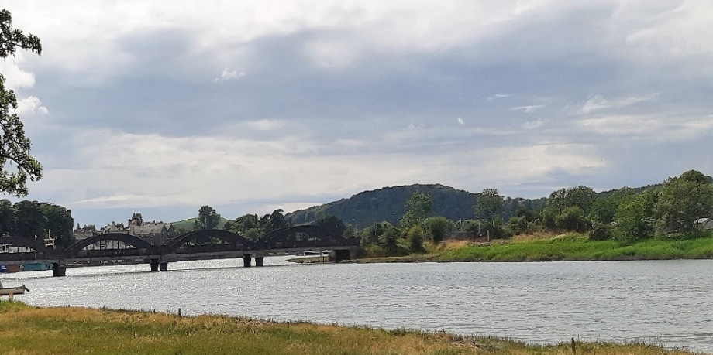
Overview
The Hydro Nation agenda facilitates science and innovation, developing talent and collaboration to inform policy and maximise the benefits of Scotland’s waters.
Actions must be taken at pace to deliver COP26 climate commitments.
Ambitious step change is making progress to deliver net zero carbon by 2040 and transform Scotland’s river-basin management.
Saving water saves carbon. Scottish Water’s ‘Urban Waters Route Map’ increases large-scale efficiencies and nature-based solutions.
Embedding the circular economy into practise helps realise water and energy efficiencies.
Partnerships, community and youth engagement are key to the success of water sustainability solutions and provide multiple benefits.

Background
The UN’s World Water Day (WWD) is observed annually on March 22nd. Since 1993, the event has sought to raise awareness of the importance of freshwater and highlight the need for action to address the global water crisis.
In aid of Scotland’s vision to be the world’s first Hydro Nation, and meeting commitments following COP26, Scotland’s World Water Day 2022 event sought to answer: what can we do to protect our valuable water resources and environment, and how should Scotland’s water community effectively engage with wider society?
The Hydro Nation event provided a forum for water professionals, researchers, policymakers, regulators, and the wider community, to share knowledge and learn from recent projects to reduce carbon emissions, build resilience to climate change and benefit from Scotland’s water resources. Over 100 delegates attended in-person and over 400 joined the live stream.

Key themes
The event was structured around key themes of 1) health and wellbeing, 2) Scotland’s water sector route map to net zero, 3) working with communities for better water infrastructure and 4) engaging with youth to promote water sustainability. The themes were explored through presentations, round table discussions and a poster exhibition. The key messages from WWD 2022 are summarised below.
- Health & wellbeing
Being close to water is good for our wellbeing. Investing in blue-green spaces helps solve climate-driven flooding, supports biodiversity, and delivers benefits including improved health, routes for active travel and provides habitat for nature. Evidence for the health benefits were described by Catherine Topley (Scottish Canals), in studies¹ with Glasgow Caledonian University, highlighting a 15% reduction in chronic diseases experienced by those living within 700 m of Scotland’s canals, demonstrating that regeneration of blue-green spaces helps society to flourish.

Bringing Scotland’s sector together towards net zero & beyond
Climate change is the biggest threat to society. Changes in water resources will be the most visible impact in Scotland, shown by both an increasing number of dry days per year and a 50% increase in rainfall intensity, leading to droughts and flooding. Karen Dee (Scottish Water) explained to delegates how intense rainfall overwhelms drainage systems and that this can be managed by adaptions to our built environment. Individual actions also have an impact on water systems and by changing our behaviour we can all do our part to reduce pressure on these systems. Campaigns to highlight the importance of binning wipes and fats (‘nature calls’) were showcased.
Mark Williams (Scottish Water) explored the hidden ‘carbon cost’ and operational footprint of providing and treating over 1 billion litres of water per day in Scotland, estimated at 250,000 tons CO₂ equivalents per year. Operational improvements towards net zero were described including using low carbon construction for upgrades to 40 water treatment works, water efficient homes, and maximising the capture of carbon using nature-based solutions (i.e., peatlands and forestry). To reach net zero, the message is clear - saving water saves carbon.
Climate change means that we need to build flood resilience and improve the condition of Scotland’s waters. Roy Richardson (SEPA) discussed how working with Scottish Water, local authorities, businesses and NGOs, they are delivering an ambitious program to restore Scotland’s river-basins. The evidence-based plans cover the period 2021-2027 and include creating over 50 community blue-green spaces such as the Tollcross Burn, Glasgow.
Amanda Lake (Jacobs) examined the opportunities offered by the circular economy within Scotland’s water sector. By keeping products and materials in use, we create efficiencies and eliminate waste. An example is the capture of biogas energy in water treatment. While there are good examples of this in Scotland, there is scope for more circular economy in the sector.

Working with communities for better water infrastructure
It is widely recognised that working in consultation with communities, towards a shared vision, helps to educate, facilitate and sustain blue-green spaces.

The Glasgow Smart Canal, provides a good example of how innovation and collaboration in a regeneration project can create economic opportunities (110 hectares of land unlocked for development), mitigate against flooding and pollution, improve wellbeing and build resilience. However, time and transformational change are needed to build new partnerships at every opportunity and to ensure an inclusive approach. Emma Ash (Consumer Scotland) described how engagement with local communities helps address concerns and reduce misunderstandings, allowing water projects to be community-driven, whilst ensuring clarity on aspects such as maintenance, ownership, and responsibilities for blue-green spaces. Blue-green spaces such as St Mary’s, Dundee, demonstrate the positive outcomes of partnership working, increasing access to safe, clean water, and empowering individuals and communities to play their role in protecting water resources.

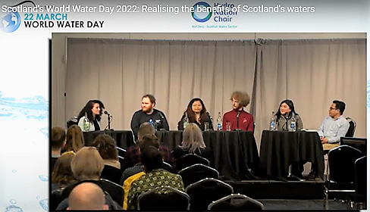
How can we better engage and inform youth on sustaining water resources?
A unique panel discussion, led by Hydro Nation scholars, Julze Alejandre and Rita Noelle Moussa, invited young researchers, leaders and professionals to share views and gave an insight into the barriers to understanding and communicating water sustainability. Ideas for engaging and empowering future generations in water stewardship included the need to avoid jargon and to provide outdoor learning experiences and to use social media to reach out and show the crucial role of water in sustaining our planet.

Scotland – A Hydro Nation
The Hydro Nation International Centre co-designs and delivers projects on water management in key territories including Malawi and India. Muthi Nhlema (BASEflow) showcased the use of technology to better monitor groundwater supplies in Malawi. BASEflow’s work is part of a range of activities that come under the Malawi-Scotland Regulatory Partnership, which sets out an innovative model of peer-to-peer partnership toward sustainable management of water resources.
The Hydro Nation Chair program supports the water sector in striving towards net zero. At WWD 2022, Andrew Tyler (Hydro Nation Chair) launched the program, setting out the mission for research and innovation, encouraging clean growth and building collaborations to meet Scotland’s climate commitments.

Conclusion
Scotland’s WWD 2022 served as a forum for science and policy interchange, raised awareness of the benefits of Scotland’s water, facilitated inclusive dialogue and collaborations, galvanized the sector to share knowledge and tackle the challenges ahead towards net zero in 2040.
“We need to make sure water plays its fullest role possible in making Scotland a great place to live in and then to take this learning to other countries so they can share that journey”, Jon Rathjen (Deputy Director, Water Policy & Directorate of Energy and Climate Change Operations Scottish Government).

